# UNH SEDS Resume Booklet

## 2019-2020

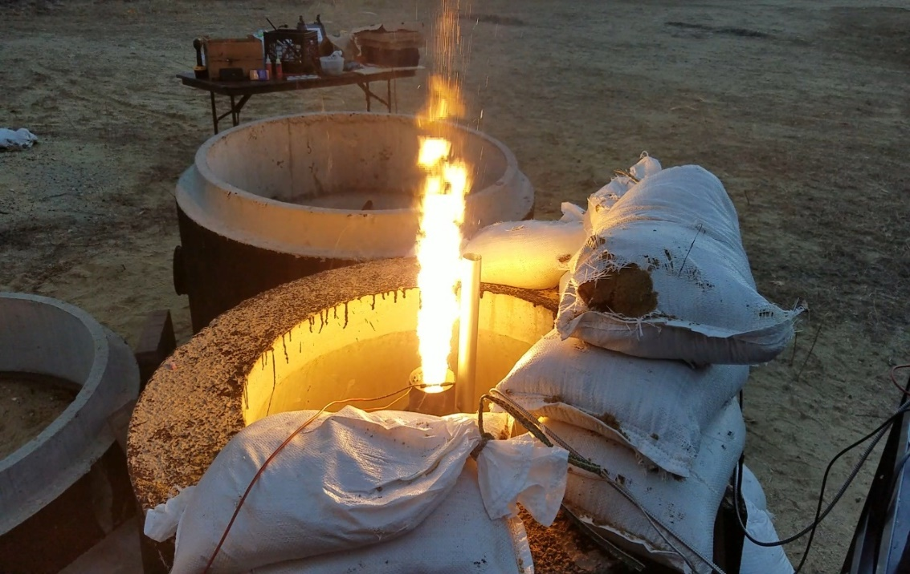

Figure 1 - Our first engine hot-fire test of Runaway, our hybrid rocket engine. This was during Year 2 of our 3-Year plan detailed below

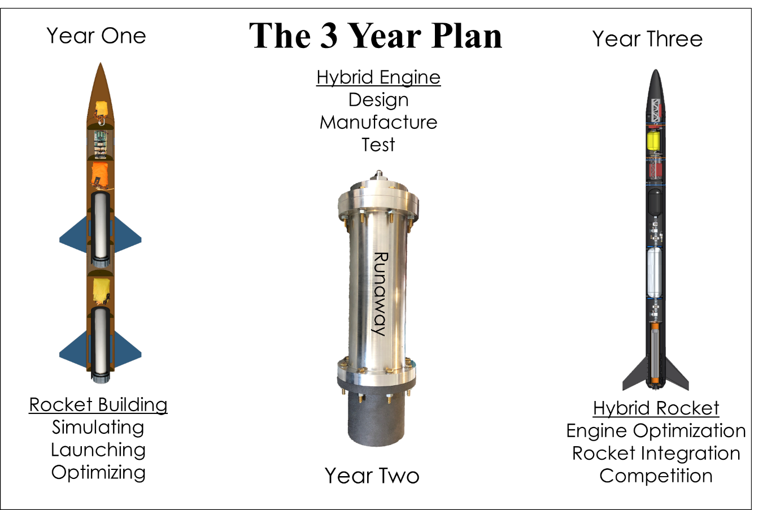

# Our Current Hybrid Rocket Engine

## From Year 2

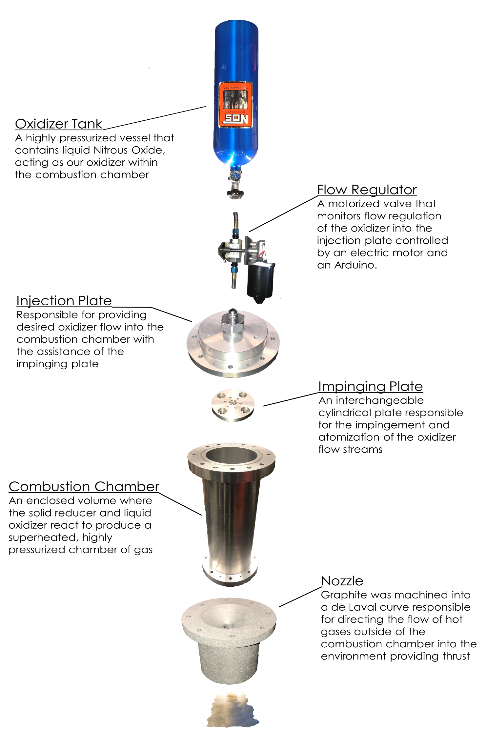

# UNH SEDS Leaders

THIS IS WHERE 8 Leads will go or something

Here we will have a list of the people that have resumes on here, major, minor and year… etc. Table of contents kinda.